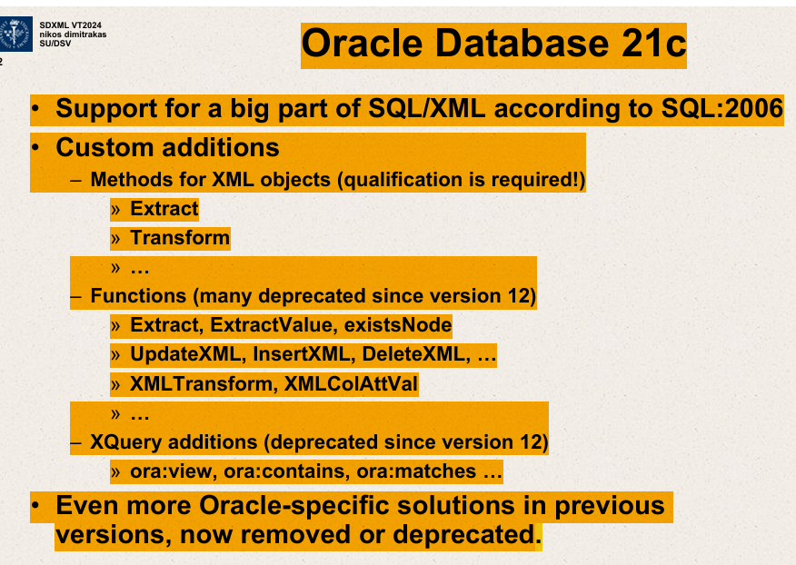

The slide provides an overview of certain features and updates related to XML processing in Oracle Database 21c. Here’s a breakdown of the main points:

1. **Support for SQL/XML as per SQL:2006**:
   * Oracle Database 21c supports a significant portion of SQL/XML, which is a standard extending SQL to incorporate XML.

This standard allows for the integration of XML data with traditional SQL queries.

1. **Custom Additions**:
   * The database includes specific methods for handling XML objects, but using them requires specific knowledge or qualifications.

Examples include methods to **Extract** and **Transform** XML data.

1. **Functions**:
   * Several XML-related functions are mentioned, many of which have been deprecated since Oracle version 12. Functions like **Extract**, **ExtractValue**, and **existsNode** are used to manipulate XML data within SQL queries. Other functions mentioned include **UpdateXML**, **InsertXML**, **DeleteXML**, which allow for modifying XML data. **XMLTransform** and **XMLColAttVal** are also listed but not detailed on the slide.
2. **XQuery Additions**:
   * XQuery, a language used to query XML data, has some Oracle-specific additions that were introduced but later deprecated in version 12. These include **ora:view**, **ora:contains**, and **ora:matches**, which likely provided specialized querying capabilities.
3. **Oracle-specific Solutions**:
   * The slide notes that previous versions of Oracle databases had more Oracle-specific solutions for XML processing, many of which have been removed or deprecated in the latest version. This suggests a move towards standardization or possibly the introduction of new, improved methodologies.

This slide seems to be part of a presentation, possibly for educational or update purposes, detailing how Oracle 21c handles XML data, highlighting the evolution of these features over different versions. If you need more specific details or explanations on how these functions work or the implications of their deprecation, feel free to ask!

Oracle database

Support for a big part of SQL/XML according to SQL:2006

Custom additions

Methods for XML objects( qualification is required)

Extract

Transform

Functions (many deprecated since version 12)

Extract,ExtractValue,existsNode

UpdateXML,InsertXML,DeleteXML

XMLTransform,XMLColAttVal

Xquery additions

ora:view,ora:contains,ora:matches

Even more oracle-specific solutions in previous versions,

Now removed or deprecated.

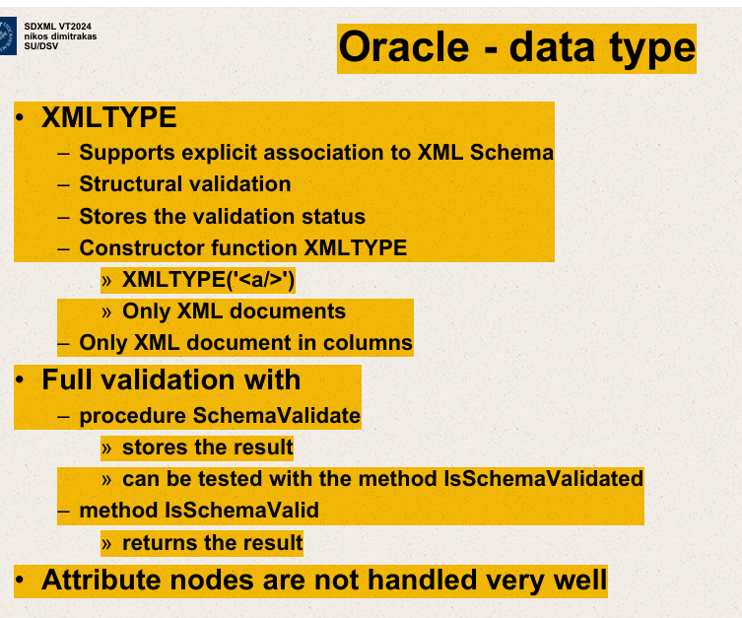

This slide provides an overview of the XMLTYPE data type in Oracle databases, highlighting its features and usage in handling XML data. Here's a breakdown of the key points:

1. **XMLTYPE Data Type**:
   * **Supports explicit association to XML Schema**: XMLTYPE can be explicitly associated with a particular XML Schema, allowing for structured data management and validation against that schema.
   * **Structural Validation**: XMLTYPE ensures that the XML data adheres to the structure defined by the associated XML Schema.
   * **Stores the validation status**: It retains information about whether the XML data has passed the schema validation.
   * **Constructor function XMLTYPE**: This function is used to create an XMLTYPE instance from XML data. The slide shows an example where a simple XML element **<a></a>** is used to create an XMLTYPE.
2. **Validation**:
   * **Only XML Documents**: This point suggests that XMLTYPE is intended to work solely with XML documents.
   * **Only XML document in columns**: This likely refers to storing XML documents in database columns that are defined as XMLTYPE.
   * **Full validation with procedure SchemaValidate**:
     + **stores the result**: Indicates that the validation results are stored, likely within the XMLTYPE data or related system tables.
     + **can be tested with the method IsSchemaValidated**: A method to check if the XML document has been successfully validated against its schema.
     + **returns the result**: The IsSchemaValidated method returns the validation result, informing if the XML data adheres to the schema.
3. **Attribute Nodes**:
   * **Attribute nodes are not handled very well**: This suggests that XMLTYPE may have limitations or less optimal handling when it comes to XML attribute nodes as opposed to elements.

Overall, this slide provides insights into how Oracle's XMLTYPE data type can be used to manage XML data within the database, ensuring that it complies with specific schemas and detailing the validation mechanisms available.

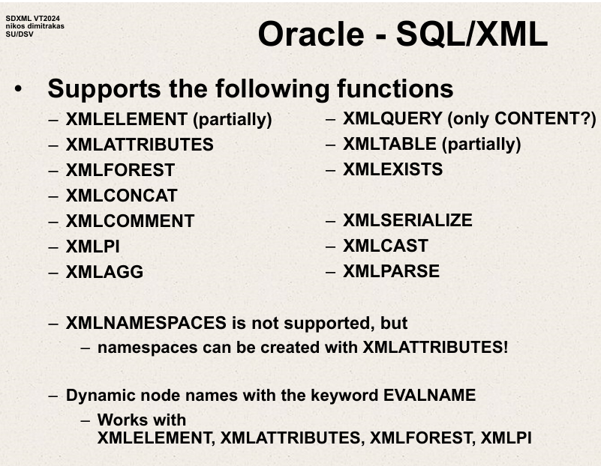

Oracle – supports the following functions

XMLELEMENT   
XMLATTRIBUTES  
XMLFOREST  
XMLCONCAT

XMLCOMMENT  
XMLPI  
XMLAGG

XMLQUERY

XMLTABLE  
XMLEXISTS

Namespaces can be created with XML attributes.

Dynamic node names with keyword EVALNAME

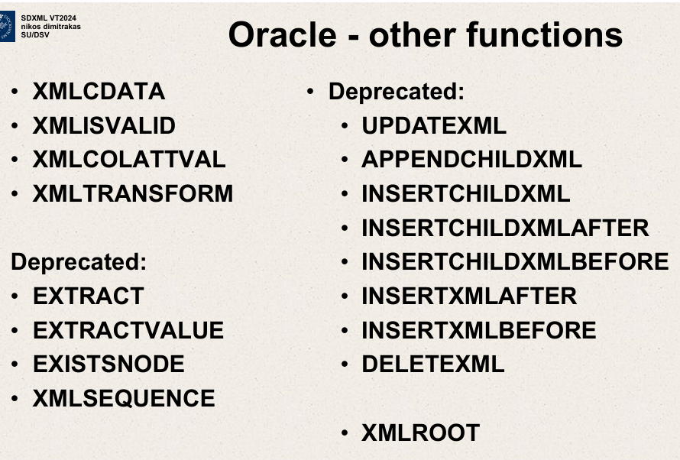

XMLCDATA  
XMLISVALID  
XMLCOLATTVAL

XMLTRANSFORM

INSERTXMLBEFORE  
INSERTXMLAFTER  
DELETEXML  
XMLROOT  
UPDATEXML

APPENDCHILDXML

INSERTCHILDXML  
INSERTCHILDXMLBEFORE  
INSERTCHILDXMLAFTER  
  
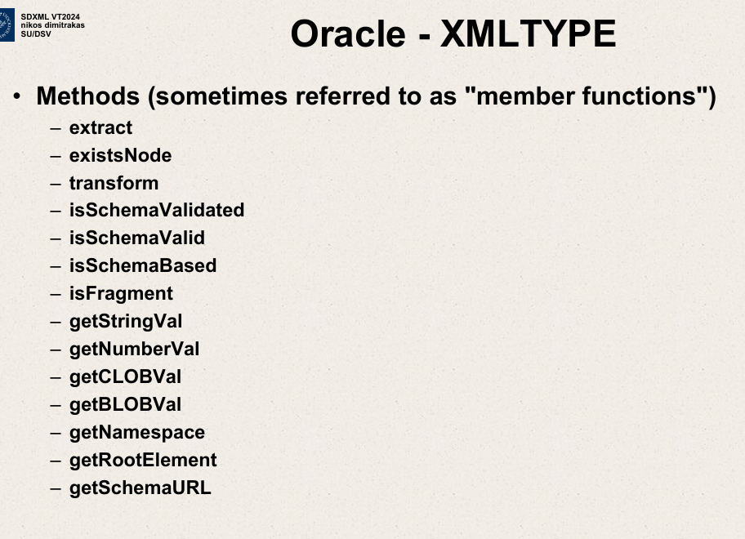

Oracle XMLTYPE methods

Sometimes referred to as member functions.

Extract

existsNode

transform

isSchemaValidated

The slide you provided lists several methods related to the **XMLTYPE** data type in Oracle Database, which is used to handle XML content. Here’s an explanation of each method mentioned:

1. **extract**: Extracts a specified XML node or element from an XML document using XPath expressions.
2. **existsNode**: Tests whether a specified XPath expression exists in the XML document. It returns a numerical value indicating the count of nodes that match the XPath expression.
3. **transform**: Transforms XML data by applying a specified XSLT stylesheet. This is useful for converting XML data into a different XML format or other text-based formats.
4. **isSchemaValidated**: Checks whether the XML document is validated against an XML schema.
5. **isSchemaValid**: Similar to **isSchemaValidated**, this function checks if the XML document adheres to the defined schema.
6. **isSchemaBased**: Indicates whether the XMLType instance is based on an XML schema.
7. **isFragment**: Determines if the XML document is a well-formed XML fragment rather than a complete XML document.
8. **getStringVal**: Converts the XML data into a string format. This is useful when the XML needs to be displayed as plain text.
9. **getNumberVal**: Converts the content of an XML element into a number. This is particularly useful when the XML element contains numeric data that needs to be used in calculations.
10. **getCLOBVal**: Retrieves the XML data as a character large object (CLOB). This is useful for handling larger XML documents that might not fit into standard string data types.
11. **getBLOBVal**: Retrieves the XML data as a binary large object (BLOB), which can be useful when the XML is stored in a binary format.
12. **getNamespace**: Returns the namespace URI of the root element of the XML document.
13. **getRootElement**: Retrieves the root element of the XML document.
14. **getSchemaURL**: Provides the URL of the XML schema that the XML document conforms to.

These methods provide a powerful set of tools for manipulating and querying XML data directly within Oracle Database, helping integrate XML handling seamlessly into SQL applications.

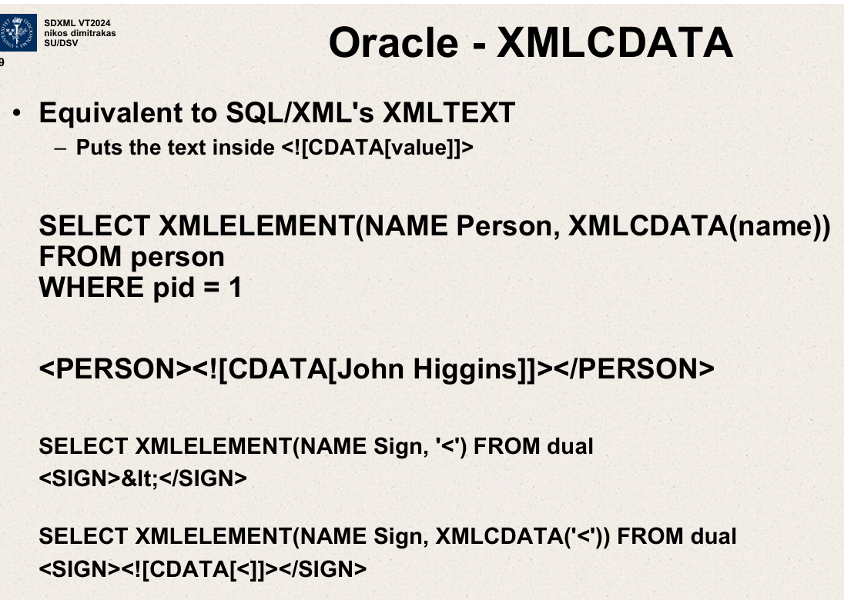

The image you've uploaded discusses the use of **XMLCDATA** in Oracle Database, particularly how it can be used in SQL/XML functions to handle XML data by encapsulating text within CDATA sections in XML outputs.

Here's a breakdown of the contents and examples given in the slide:

**XMLCDATA**

* **Purpose**: The **XMLCDATA** function in Oracle is used to generate CDATA sections in XML. This is particularly useful for ensuring that the contents inside the CDATA section are treated as character data and not parsed as XML markup.

**Examples**

1. **Example 1**: **SELECT XMLELEMENT(NAME Person, XMLCDATA(name)) FROM person WHERE pid = 1**
   * This SQL query uses the **XMLELEMENT** function combined with **XMLCDATA**. It creates an XML element named **<PERSON>** for a person with a specific ID (**pid = 1**). The person's name is inserted within a CDATA section.
   * **Output**: **<PERSON><![CDATA[John Higgins]]></PERSON>**
   * Here, "John Higgins" is encapsulated within a CDATA section to ensure that it is treated purely as text, even if it contains characters that could be interpreted as XML markup.
2. **Example 2**: **SELECT XMLELEMENT(NAME Sign, '<') FROM dual**
   * This query attempts to create an XML element **<SIGN>** containing the less-than symbol (**<**), which is a special character in XML.
   * **Output**: **<SIGN>&lt;</SIGN>**
   * Oracle automatically escapes the less-than symbol to prevent it from being mistaken for the start of a tag.
3. **Example 3**: **SELECT** XMLELEMENT**(NAME Sign, XMLCDATA('<')) FROM dual**
   * Similar to the previous example, but this time using **XMLCDATA** to handle the special character.
   * **Output**: **<SIGN><![CDATA[<]]></SIGN>**
   * The less-than symbol is now inside a CDATA section, preventing it from being parsed as XML and displayed exactly as intended.

These examples illustrate how CDATA sections can be used to encapsulate data that might otherwise interfere with the parsing of XML, ensuring that the data is treated as plain text. This functionality is crucial when handling free-text input that may contain characters that are part of the XML syntax.

SELECT XMLELEMENT (NAME Sign,’<’) FROM dual

<SIGN> &It;</SIGN>

SELECT XMLELEMENT(NAME Sign,XMLCDATA(‘<’)) FROM dual

<SIGN> <![CDATA[<]]></SIGN>

Oracle – XMLISVALID

Equivalent to SQL/XML’s XMLVALIDATE.

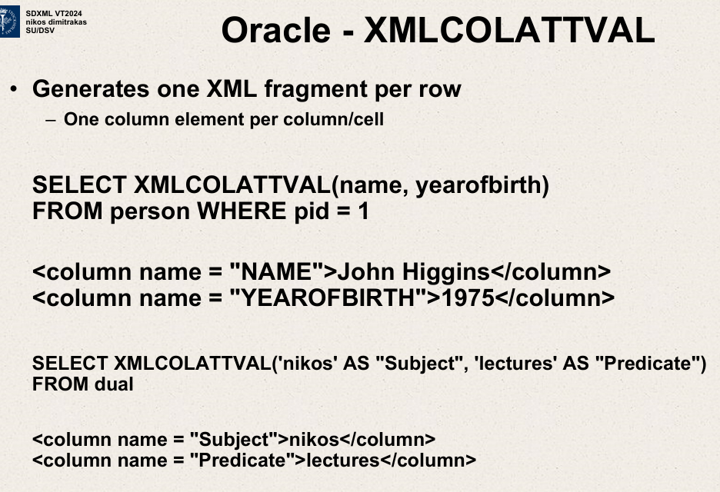

Generates one XML fragment per row.

One column element per column/cell.

SELECT XMLCOLATTVAL (name, yearofbirth)

FROM person WHERE pid=1.

-one column element per column/cell

<column name=”NAME”> John Higgins </column>

<column name=”YEAROFBIRTH”> 1975 </column>

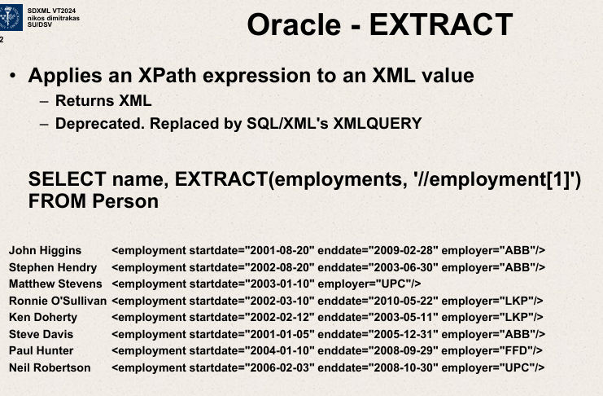

Applies Xpath expression to an XML value

Returns XML

Replaced by xquery in later oracle versions

Gets all the first employments of the person.

Applies an Xpath expression to an XML value.

SELECT name, EXTRACT (employments,’//employment[1]’)

FROM Person

John Higgins <employment startdate=”” enddate=”” employer=””>

The image you've uploaded discusses the use of the **EXTRACT** function in Oracle, specifically for extracting parts of XML data using XPath expressions. Here's a detailed explanation based on the contents shown in the slide:

**Oracle - EXTRACT**

* **Purpose**: The **EXTRACT** function applies an XPath expression to an XML value and extracts parts of the XML document.
* **Output**: Returns the extracted XML as specified by the XPath.
* **Note**: This function is deprecated and has been replaced by **XMLQUERY** in more recent versions of Oracle.

**Example Use Case**

The slide provides an SQL example and illustrates the output when using the **EXTRACT** function:

SELECT name, EXTRACT(employments, '//employment[1]') FROM Person

* **Purpose**: This query is designed to retrieve the name of each person from a database table called **Person**, along with the first **<employment>** node from an XML document stored in the **employments** column of the same table.

**Output:**

* Each row in the output lists a person's name followed by the XML snippet of their first employment record.
* The XML snippet includes attributes such as **startdate**, **enddate**, and **employer**, reflecting details of the first job recorded for each person.

**Example Output:**

* **John Higgins**: **<employment startdate="2001-08-20" enddate="2009-02-28" employer="ABB"/>**
* **Stephen Hendry**: **<employment startdate="2002-02-20" enddate="2003-06-30" employer="ABB"/>**
* And so on for each person listed.

**Importance:**

The **EXTRACT** function is useful for SQL/XML operations where you need to extract specific parts of an XML structure based on your requirements. Although deprecated, this function may still be seen in legacy systems or in contexts where old versions of Oracle Database are used. The use of XPath makes it versatile for accessing deeply nested or specific XML data.

This example provides clear insight into how **EXTRACT** is implemented in Oracle SQL for retrieving XML data, allowing for complex data structures to be parsed and utilized directly within SQL queries.

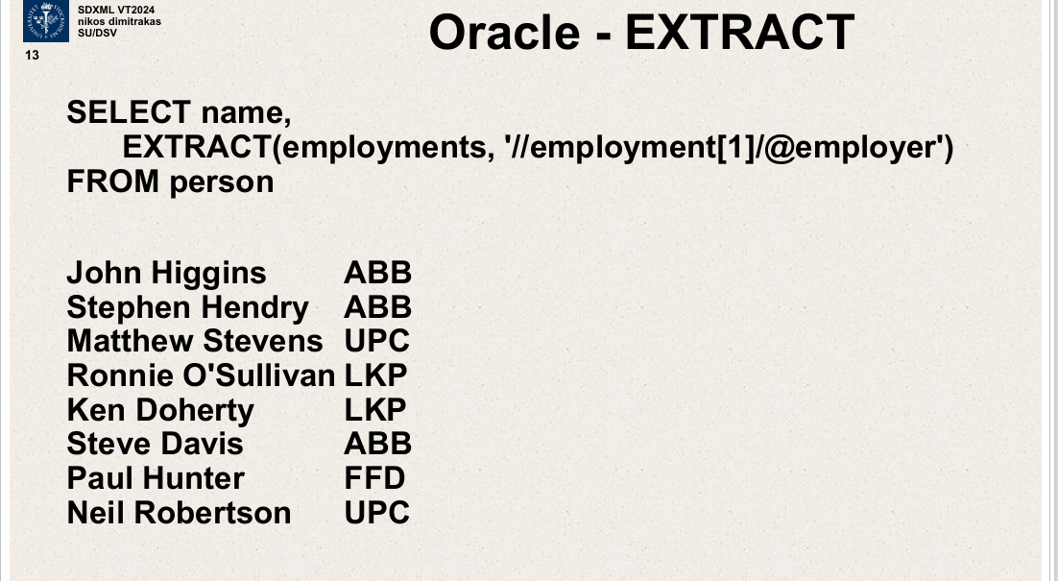

SELECT name,

EXTRACT (employments ,’//employment[1]/@employer’)

FROM person

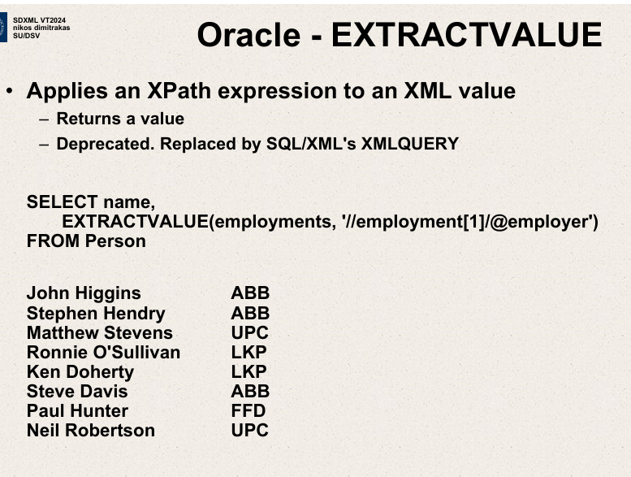

SELECT name,EXTRACTVALUE (employments,”//employment

[1]/@employer”)

FROM Person

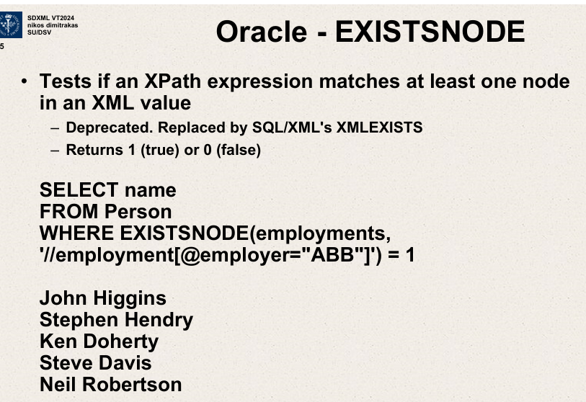

EXISTSNODE – Tests if an Xpath expression matches atleast one node in an XML value.

Deprecated – replaced by SQL/XML’s XMLEXISTS  
Returns 1(true) or 0 (false)

SELECT name

FROM Person

WHERE EXISTSNODE (employments,’//employment[@employer=”ABB”]’)=1

XMLSEQUENCE  
- splits an XML fragment/sequence into many XML values.

SELECT e.*

FROM Person, TABLE( XMLSEQUENCE (EXTRACT(employments,’//employment’))) e

WHERE pid=5

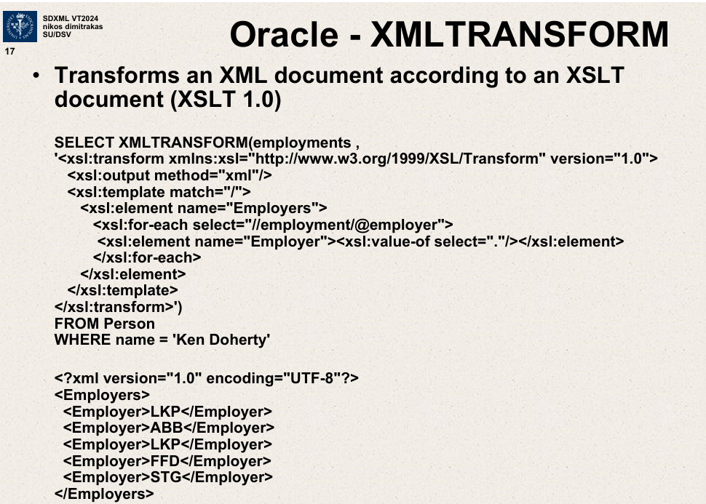

Transforms an XML document according to a XSLT document.(XSLT 1.0)

SELECT XMLTRANSFORM (employments,

<xsl:transform xmlns:xsl=””>

<xsl:output method=”xml”/>

<xsl:template match=”/”>

<xsl:element name=”Employers”>

<xsl:for-each select=”//employment/@employer”>

<xsl:element name=”Employer”> <xsl:value-of select=”.”/>

</xsl:element>

</xsl:for-each> </xsl:element> </xsl:template> </xsl:transform>’)

FROM Person

WHERE name= ‘Ken Doherty’

Ken Doherty has pid 5

SELECT XMLTRANSFORM (employments,

)  
FROM Person

WHERE name=”Ken Doherty”

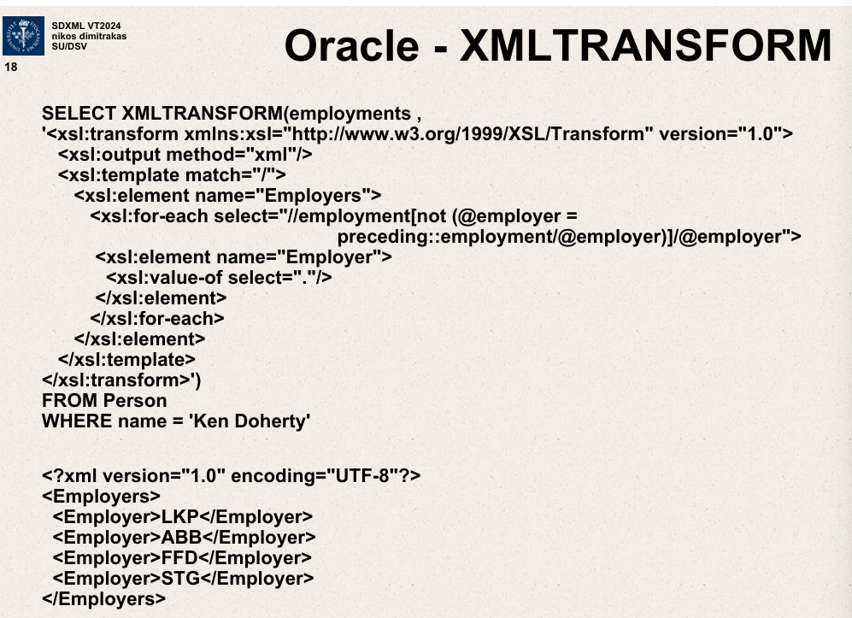

Employers

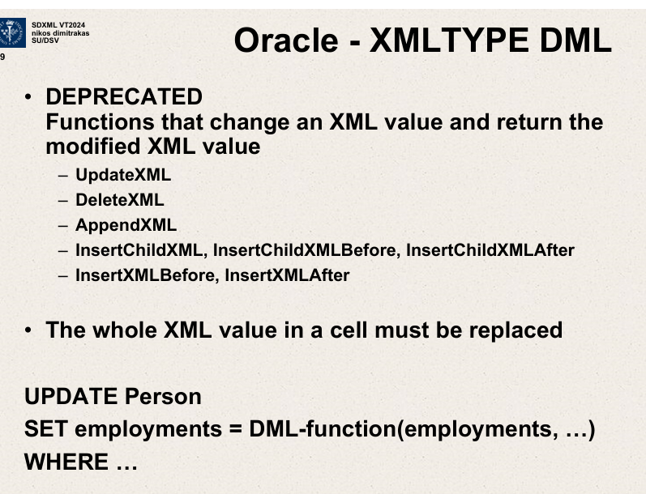

Functions that change an XML value and return the modified XML value.

XMLTYPE

* Supports explicit association to XML schema
* Structural validation
* Stores the validation status
* Constructor function XMLTYPE

XMLTYPE(‘<a/>’)

Only XML documents.

Only XML document in columns.